

# rubrics in turnitin

## A guide to incorporating academic and communication skills for RMIT Teaching Staff

This guide shows you how to incorporate rubrics for assessing academic and communication skills into your assessment of Turnitin assignments. For an explanation of the rubrics and how and why to use them to support your teaching, see the tutorial on the Learning Lab under *Resources for Staff > Assessment > Using Rubrics*.

There are several versions of the Academic Communication Skill rubric, varying in level of detail, number of criteria and grading scales. These are listed on the ‘Choosing a rubric’ tab of the Rubrics tutorial in the Learning Lab. Choose the one that best suits your needs, then follow the steps below to use it with your Turnitin assignment.

## To create a new Turnitin assignment

1. Log in to [Blackboard](https://learninghub.rmit.edu.au) and click on your course name.
2. In the top menu block on the left (under the course name heading), go to ‘Assessment tasks’.
3. Under the Assessments drop down menu, choose ‘Turnitin Assignment’.
4. Select the assignment type and click ‘Next Step’.
5. Complete the assignment details and click ‘Submit’ and then click ‘Ok’

Now that you have an assignment configured, you can follow the steps in the relevant sections below to apply a new or customised rubric to this assignment.

## To launch the Rubric/Form Manager

In order to create, import, duplicate and edit the available rubrics, you will need to launch the Rubric/Form manager as follows.

1. Log in to [Blackboard](https://learninghub.rmit.edu.au).
2. Click the relevant course under ‘My programs and courses’.
3. Go to Control panel > Course tools > Turnitin Assignments.
4. Click on the assignment name.
5. Click on the ‘Libraries’ tab.
6. Click ‘Rubric/Form Manager’.

**Important:** After altering your rubric, **don’t forget to save your changes**.



## To create a new rubric

**Important**: If you have not yet created a Turnitin assignment, do that first (see above). Do not be tempted to create a rubric directly from the course tools section of the Blackboard control panel. You will not be able to add it to a Turnitin assignment.

1. Launch the Rubric/Form Manager.
2. Rubric options iconClick the Rubric options icon.
3. Select ‘Create new rubric’.
4. Enter a name for your rubric (up to 30 characters).
5. At the bottom of the screen, choose a scoring method: percentage, custom values or qualitative (‘0’ or no numeric scoring).
6. Click in any cell to edit the text, including criterion and scale names.  
   N.B. The following character limits apply:
   * rubric name: 30
   * criterion title: 13
   * scale title: 25
   * description text: 1000
7. 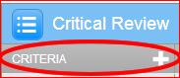To add extra rows of criteria or scale columns, click on the ‘+’ icon to the right of the relevant header.   
   Examples of criteria are ‘Content’, ‘Structure’ and ‘Language’. Examples of scales are ‘Excellent, Satisfactory’ and ‘Unsatisfactory’.

Note that new criteria are always added at the bottom and new scales at the right. They cannot be reordered.

1. Click ‘SAVE’ at the bottom right of the Rubric/Form Manager to save your work in progress or your completed rubric.

## To add academic and communication skills content to your rubric

**Note that the original Academic & Communication Skill rubric cannot be edited**. To combine it with your own criteria, first create your own rubric with your content, and then add appropriate content from the Academic & Communication Skill rubric as follows:

1. Launch the Rubric/Form Manager.
2. Rubric options iconClick the Rubric options icon.
3. Select your rubric from the list.
4. If necessary, add new criteria by clicking on the plus sign.
5. In a new window, go to the Learning Lab under *Resources for Staff > Assessment > Using Rubrics > Choosing a rubric tab*, and open the academic and communication rubric most relevant to your assignment type and number of scales.
6. Copy and paste text from the Learning Lab rubric into your Turnitin rubric where appropriate.
7. Click ‘SAVE’ at the bottom of the window.

## To add a rubric to an assignment

1. Log in to [Blackboard](https://learninghub.rmit.edu.au).
2. Click the relevant course under ‘My programs and courses’.
3. Go to Control panel > Course tools > Turnitin Assignments
4. Click on assignment link.
5. Click on the ‘Edit assignment’ tab.
6. Expand ‘Optional settings’.
7. Select your rubric from the list to attach it to the current assignment.
8. Finally, click ‘Submit’ to save the assignment settings.

## To give feedback using QuickMarks

QuickMarks is a convenient tool for adding frequently used comments to a student’s assignment. There are several built-in QuickMarks as well as the ‘RMIT – Academic and Communication Skills Quick Marks’ set.

1. In Turnitin, click on a student’s submission to open the document viewer.
2. The right hand pane will open in the GradeMark QuickMarks view by default.
3. Choose a QuickMarks set from under the list icon at the top of the right hand pane.
4. Hover over a blue label to see the description in the preview pane below.
5. Drag and drop a label onto the student’s assignment where relevant.
6. Hover over the QuickMark label in the text to expand it.
7. Add your own comment by clicking the ‘Edit’ button.
8. 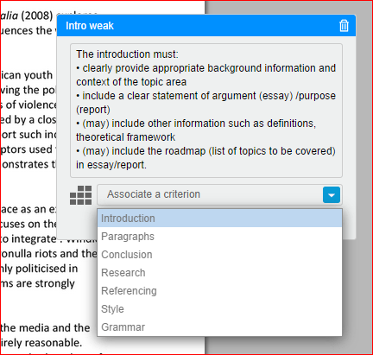You can also associate the QuickMark comment with a rubric criterion. Click the arrow next to ‘Associate a criterion’ and choose from the list. (You must have a rubric attached to the assignment to do this.)

## To give feedback using the rubric

1. In Turnitin, click on a student’s submission to open the document viewer.
2. 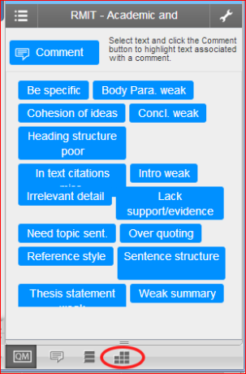The right hand pane will open in the GradeMark QuickMarks view by default. Click the rubrics icon at the bottom to switch to the rubric view.
3. 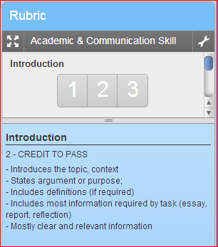Hover the mouse over a criterion ‘score’ to see the full description in the panel beneath.
4. 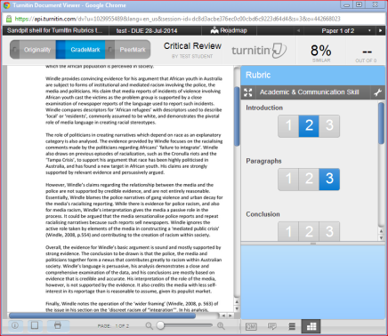Click the appropriate level/score for to assign a grade for each criterion.

Note that unless you have incorporated the criteria into a quantitative rubric and assigned scores, the feedback for the student will be purely qualitative.

## To find out more

For more on using rubrics in Turnitin, see the articles in the Turnitin Help Center under Instructor > GradeMark >Rubrics (<http://goo.gl/rf3eto>) or QuickMark (<http://goo.gl/iSD1f8>).